Tkinter notes

Tkinter introduction:
Tkinter is Python's standard GUI (Graphical User Interface) library. It's a wrapper around the Tk toolkit, which is simple, cross-platform, and comes bundled with most Python installations. You don't need to install anything extra.

First tkinter program:
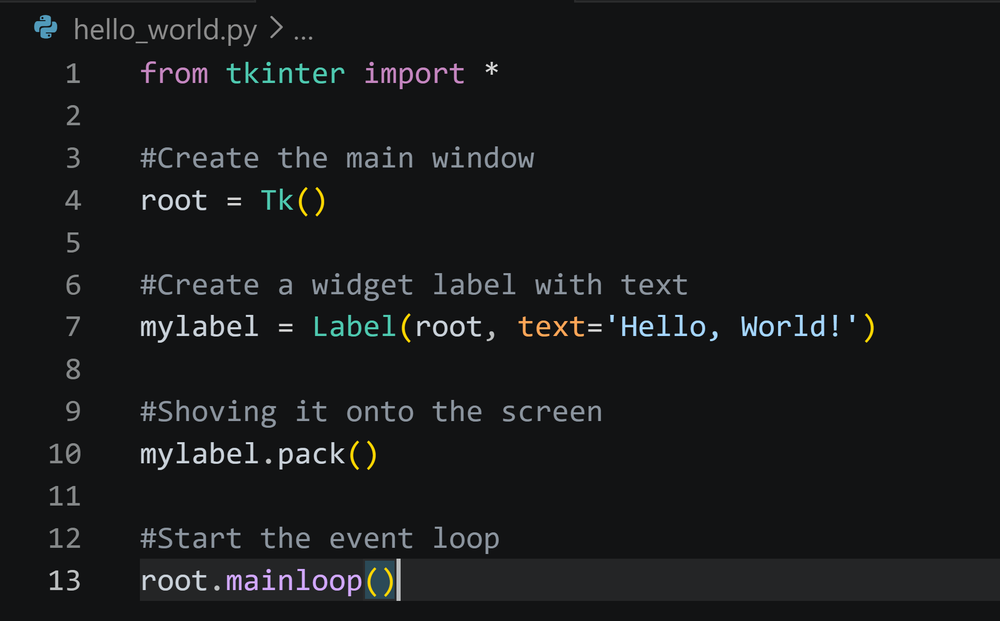

1. The Import: from tkinter import *

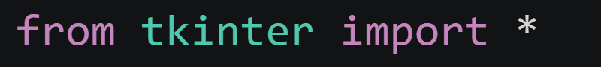
- This imports all classes and functions from the tkinter module directly into your namespace.
- You can now write Tk(), Label(), etc., instead of tk.Tk().

2. The Main Window: root = Tk()
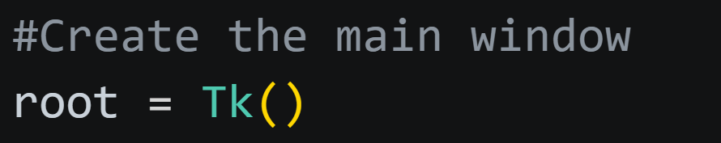
- Tk() creates the main application window – the "root" window.
- This window is the foundation. All other widgets (like labels) are placed inside it (or inside frames that are inside it).
- You can only have one Tk() instance in a program. If you need additional windows, you use Toplevel().

3. Creating Labels: Label(root, text="...")
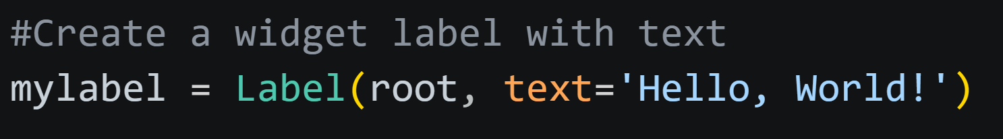
- Label is a widget that displays text (or an image).
- The first argument (root) is the parent – it tells tkinter that these labels belong to the main window.
- text is a keyword argument that sets the displayed text.
- At this point, the labels exist in memory, but they are not visible on the screen. You must use a geometry manager (like pack() or grid()) to display them.

4. The Event Loop: root.mainloop()
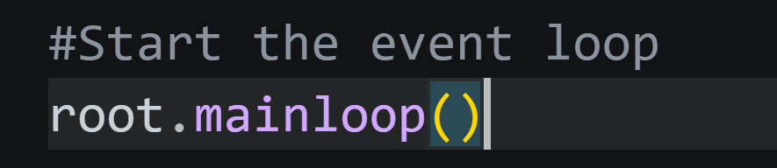
- This starts tkinter's event loop – it keeps the window open and waits for user interactions (clicks, key presses, etc.).
- Without this line, the window would appear and disappear immediately.

Second Tkinter program:
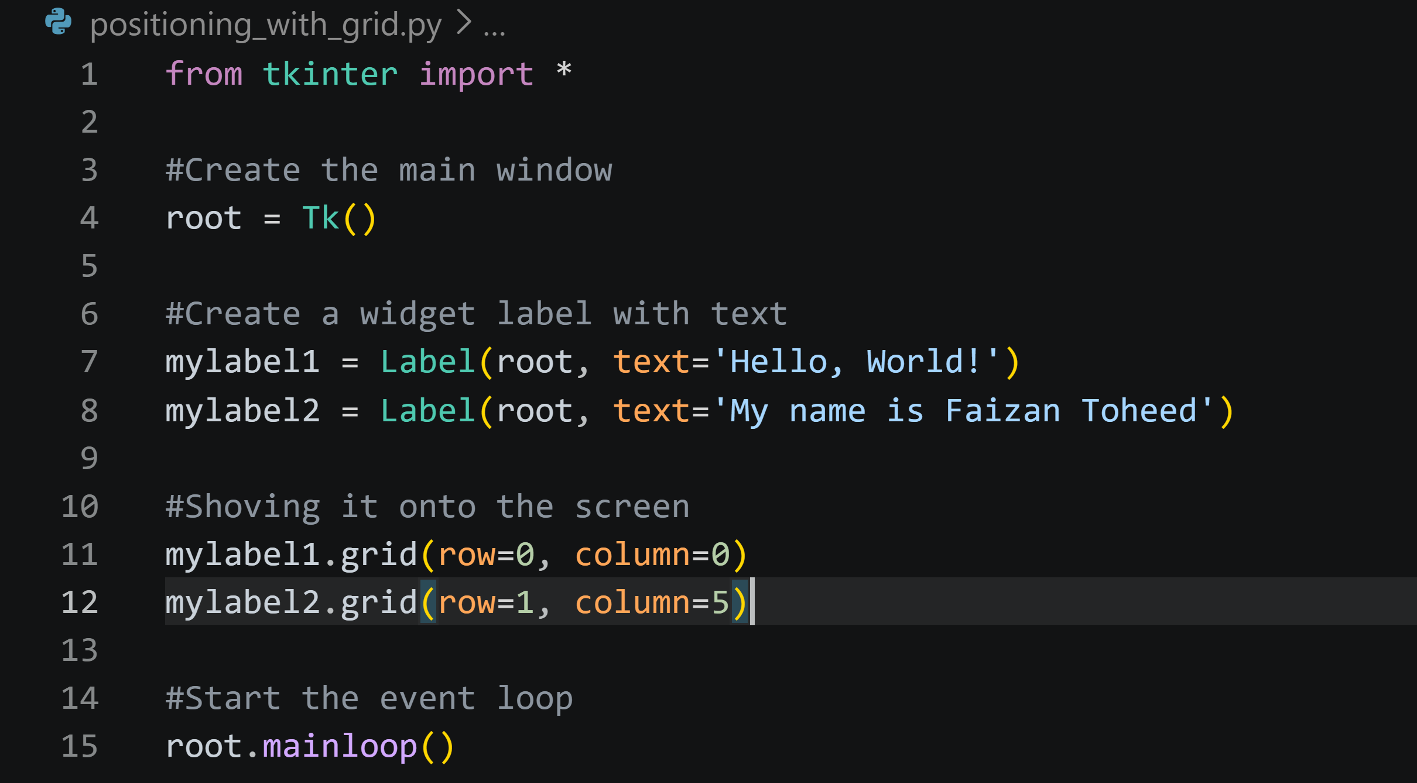

1. Positioning with grid()

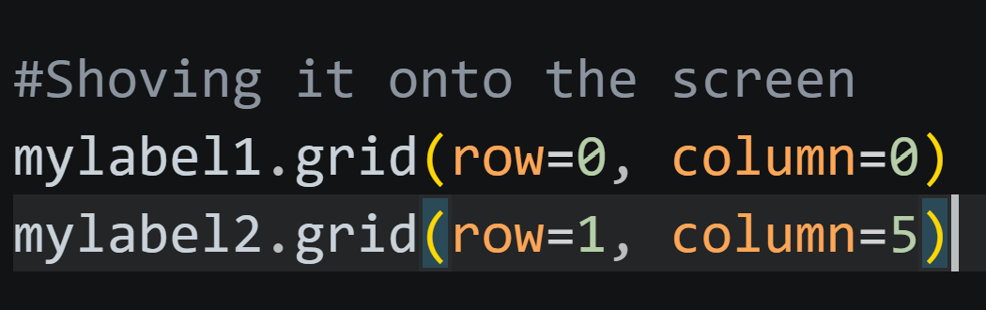
- grid() places widgets in a table-like structure using rows and columns.
- Rows and columns start at 0.
  - row=0, column=0 puts myLabel1 in the top-left cell.
  - row=1, column=5 puts myLabel2 in the second row, sixth column (since column index starts at 0).
- What about columns 1–4?
They are empty. Grid allows you to skip columns; those cells simply remain empty. This is fine.
- How does grid decide column widths?
Each column's width is determined by the widest widget in that column. Since column 5 contains myLabel2, column 5 will be at least as wide as that label. Columns 1–4 have no widgets, so they have zero width (invisible).

Third tkinter program:
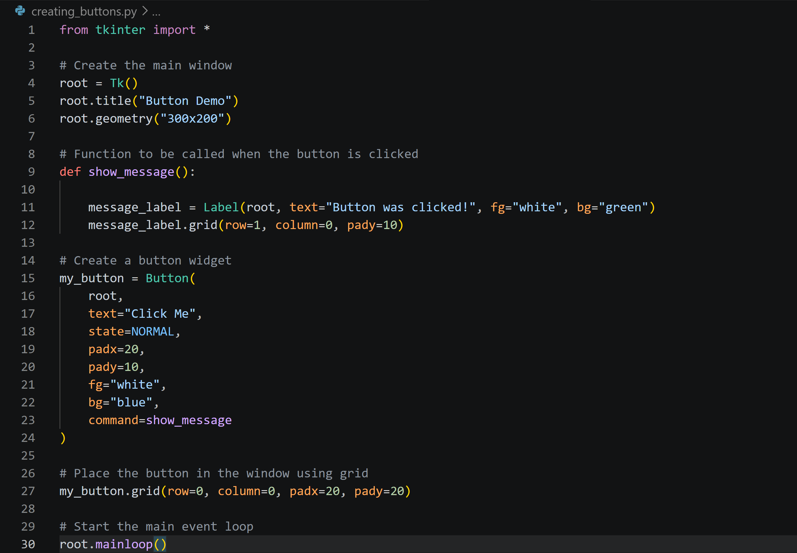

1. Creating a Simple Button
- Button is the widget class.
- First argument (root) is the parent (main window).
- text sets the label on the button.

2. Button State
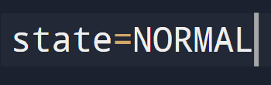
- NORMAL – the button is enabled and clickable.
- DISABLED – the button is grayed out and cannot be clicked.
- ACTIVE – the appearance when the mouse is over the button (usually set automatically, but you can force it)

3. Padding (padx / pady)
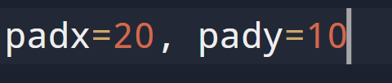
- padx adds horizontal space inside the button (between text and edges).
- pady adds vertical space inside the button.
- You also used external padding in grid(): padx=20, pady=20 – that adds space outside the button.

4. Colors (fg / bg)
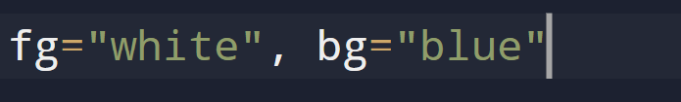
- fg = foreground color (text color).
- bg = background color (button color).
- In the show_message() function, we also set colors for the new label:

5. Getting Output from Button – The command Option

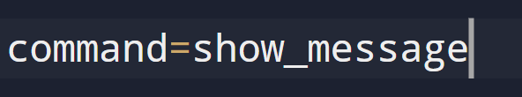
- command expects a function name (without parentheses). When the button is clicked, tkinter calls that function.
- Inside show_message(), we create a new Label widget and place it. This demonstrates that the button can trigger any code you want.

Fourth tkinter program:
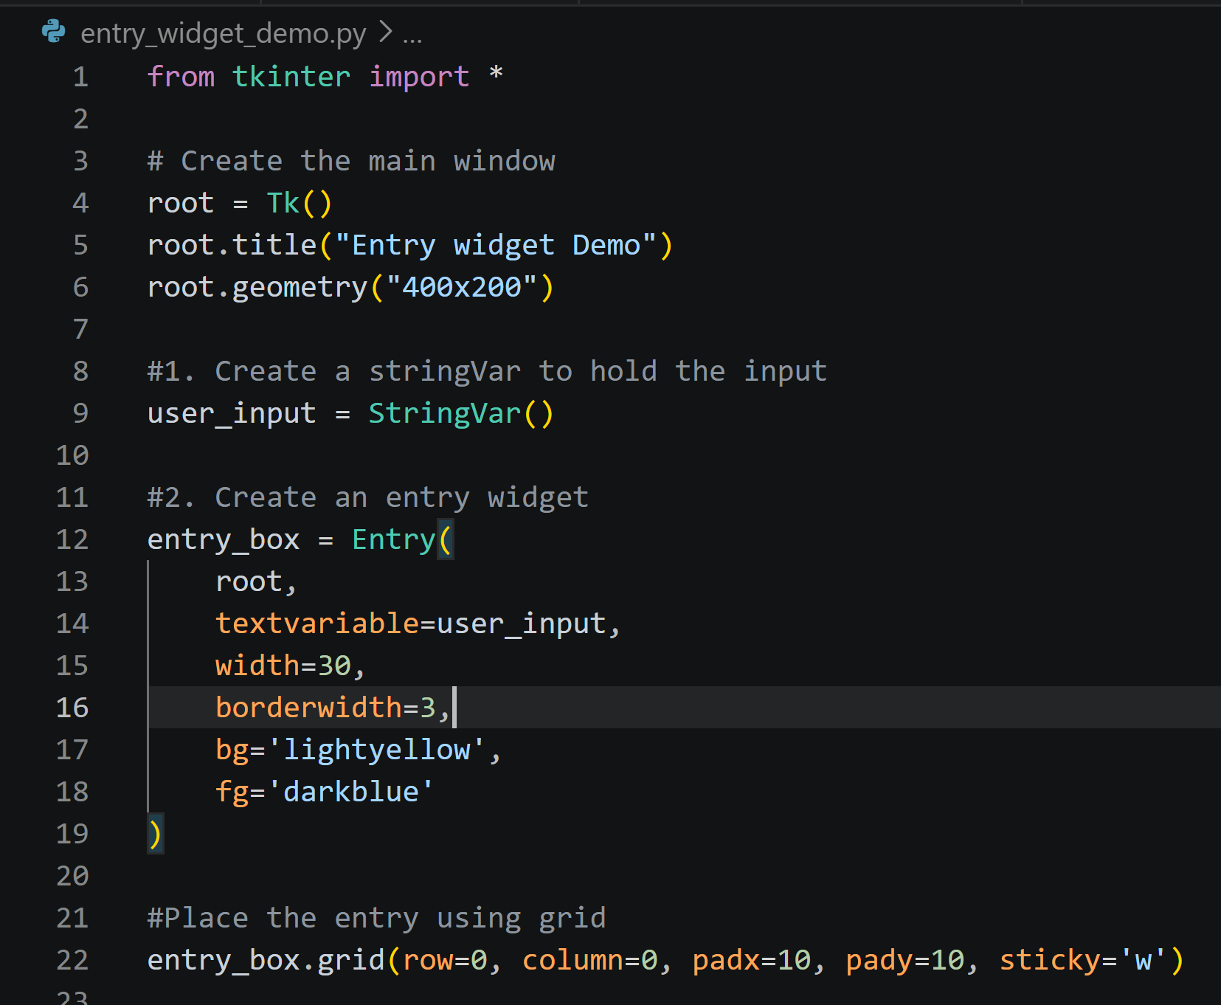
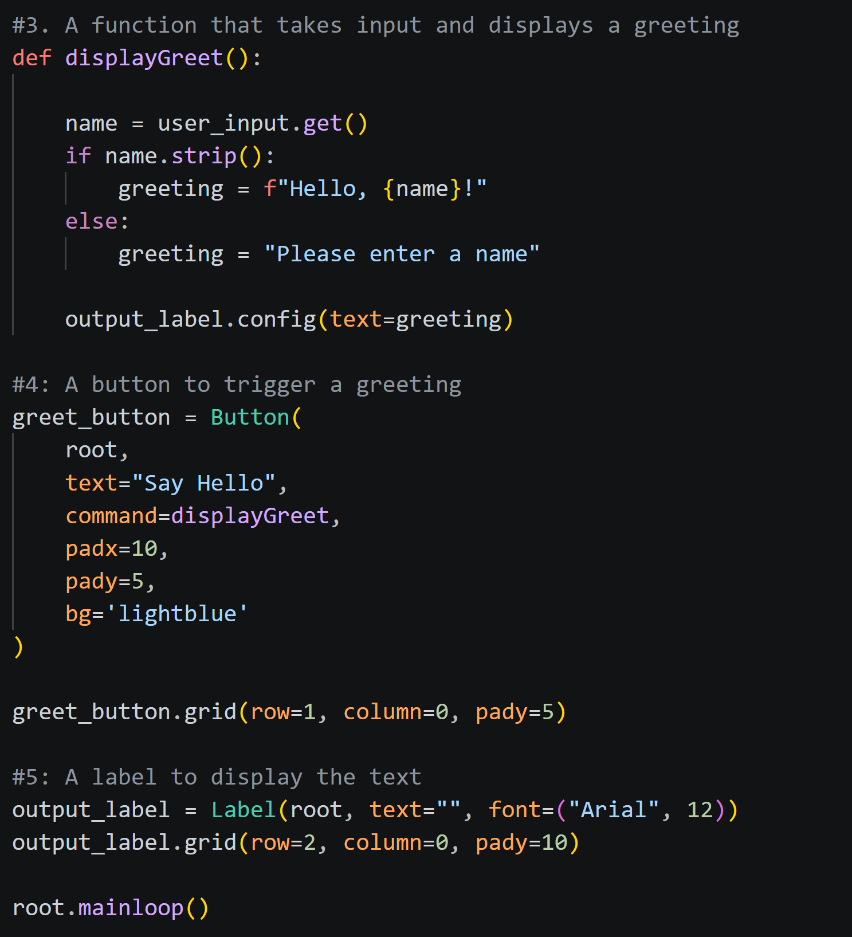

Line by line explanation
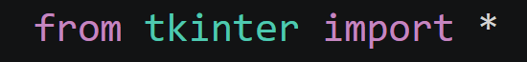
- Imports all classes, functions, and constants from the tkinter module into the current namespace.
- This allows us to write Tk() instead of tk.Tk(), Label() instead of tk.Label(), etc.
- Note: While convenient for small scripts, it can lead to name conflicts in larger programs.
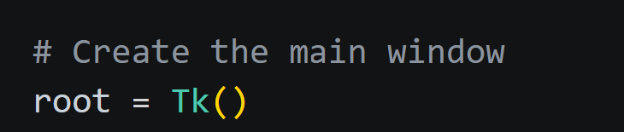
- Tk() is the constructor that creates the root window – the main application window.
- This window is the parent for all other widgets.
- The variable root holds a reference to this window, allowing us to configure it later.
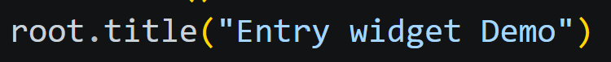
- Sets the title of the root window. The title appears in the window's title bar.
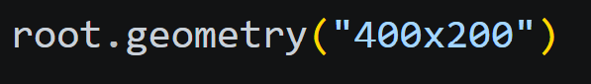
- Sets the initial size of the window: 400 pixels wide and 200 pixels tall.
- Without this, the window would shrink to fit its contents.
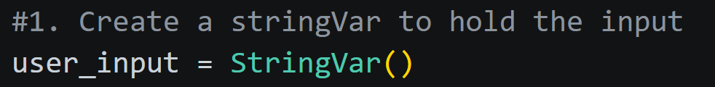
- StringVar is a special Tkinter variable class that holds a string.
- It can be linked to widgets (like Entry) so that changes in the widget automatically update the variable, and vice versa.
- Here, user_input will store whatever the user types into the entry field.
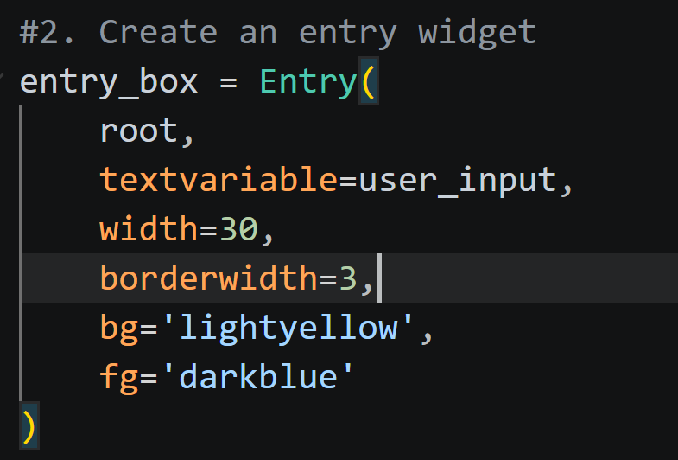
- Entry creates a single-line text input field.
- Arguments:
  - root – the parent window (or frame) that contains this widget.
  - textvariable=user_input – ties the entry's content to the StringVar. When the user types, user_input is automatically updated.
  - width=30 – the visible width in characters (not pixels).
  - borderwidth=3 – thickness of the border around the entry (default is 2).
  - bg='lightyellow' – background color of the entry field.
  - fg='darkblue' – foreground (text) color.
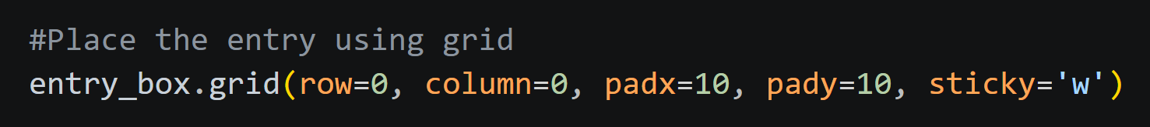
- grid() is a geometry manager that arranges widgets in a table of rows and columns.
- row=0, column=0 places the entry in the top-left cell.
- padx=10, pady=10 adds 10 pixels of external padding around the widget (space between the widget and the cell edges).
- sticky='w' aligns the widget to the west (left) side of the cell. Without this, the entry would be centered horizontally inside its cell.
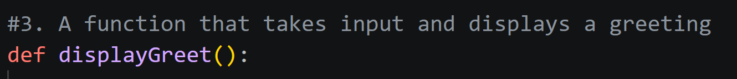
- Defines a function named displayGreet. This function will be called when the button is clicked.
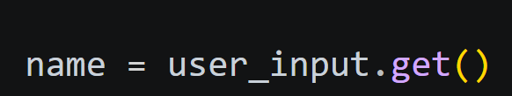
- Calls the get() method on the StringVar to retrieve the current text the user typed.
- The result is stored in the variable name.
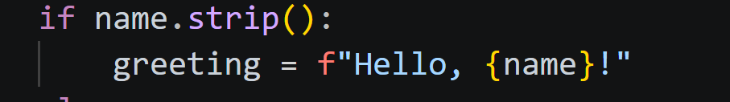
- strip() removes leading and trailing whitespace from the string.
- If after stripping the string is not empty, the condition is True (meaning the user entered something).
- If the user entered only spaces or nothing, strip() returns an empty string, which is False in a boolean context.
- If the user entered a name, we construct a greeting string using an f-string.
- This greeting will be displayed.
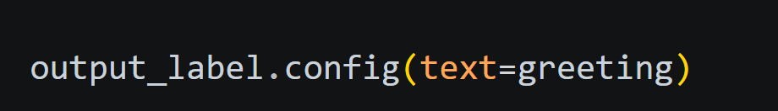
- output_label is a Label widget defined later.
- .config() (or .configure()) changes the widget's options after creation.
- Here, we set its text option to the greeting we just built.
- This updates the label's displayed text.
- Note: This line is executed regardless of the if condition; the variable greeting is always set.
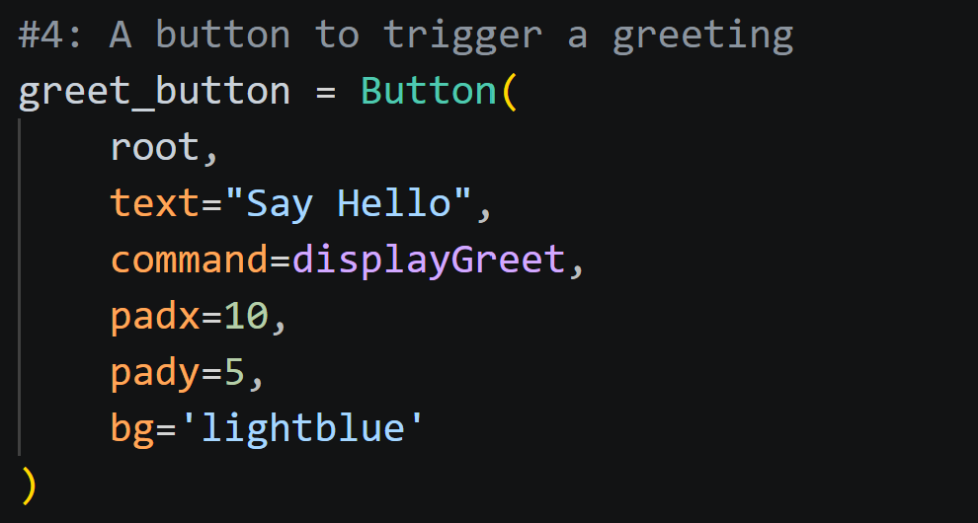
- Button creates a clickable button.
- root is the parent.
- text="Say Hello" – the label on the button.
- command=displayGreet – specifies the function to call when the button is clicked. Note: we write the function name without parentheses – we are passing the function itself, not calling it.
- padx=10, pady=5 – internal padding inside the button, making it larger.
- bg='lightblue' – background color of the button.
- Places the button in row 1, column 0 (directly below the entry).
- pady=5 adds 5 pixels of vertical space above the button (external padding).
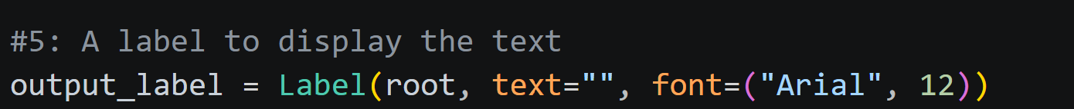
- Creates a Label widget to display the greeting.
- Initially, its text is empty.
- font=("Arial", 12) sets the font family to Arial and size to 12 points.
- Places the label in row 2, column 0 (below the button).
- pady=10 adds 10 pixels of vertical space above the label.
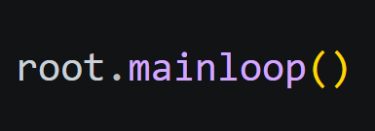
- Starts Tkinter's event loop.
- This keeps the window open, waiting for user interactions (mouse clicks, key presses, etc.).
- The program will run until the user closes the window.

Fifth tkinter program

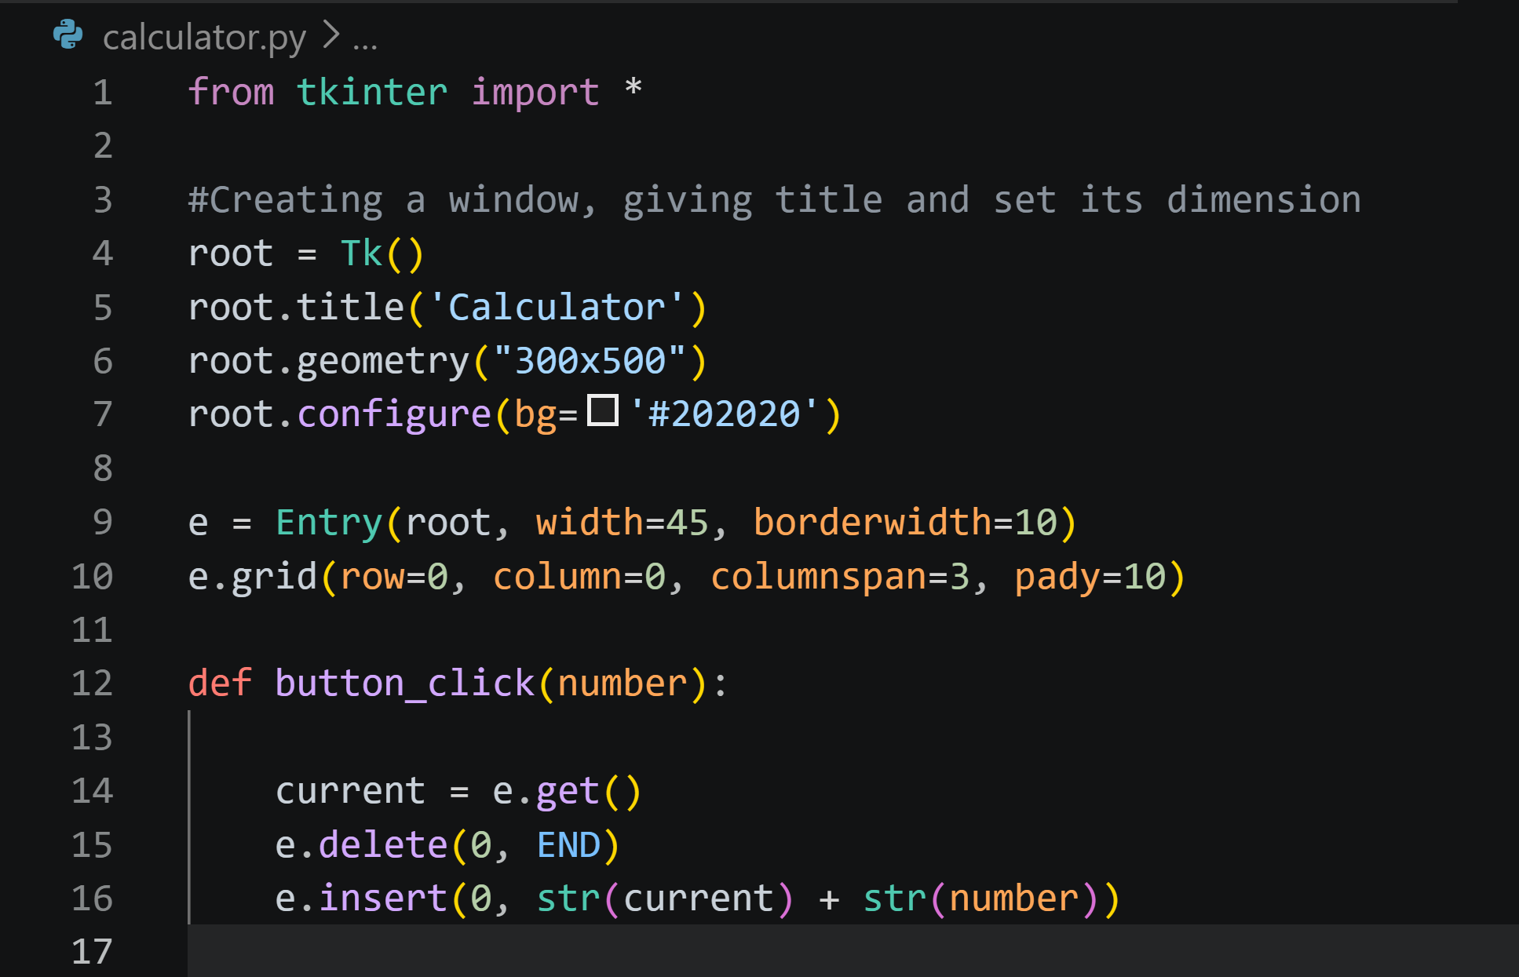
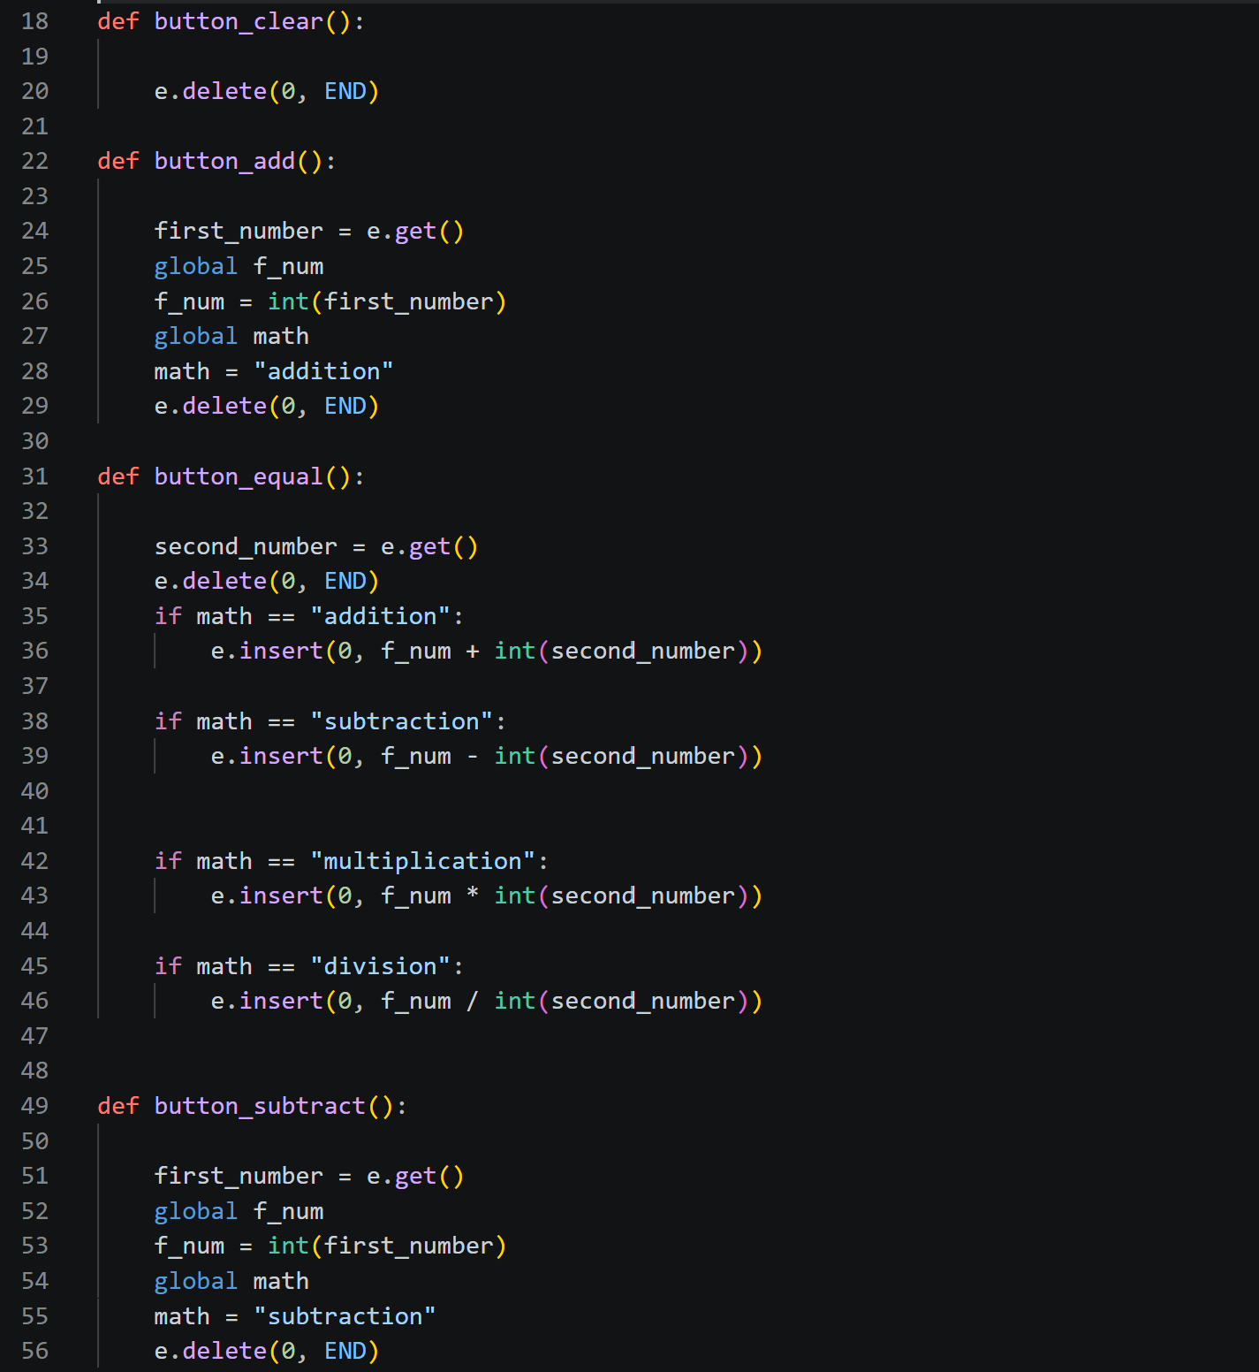
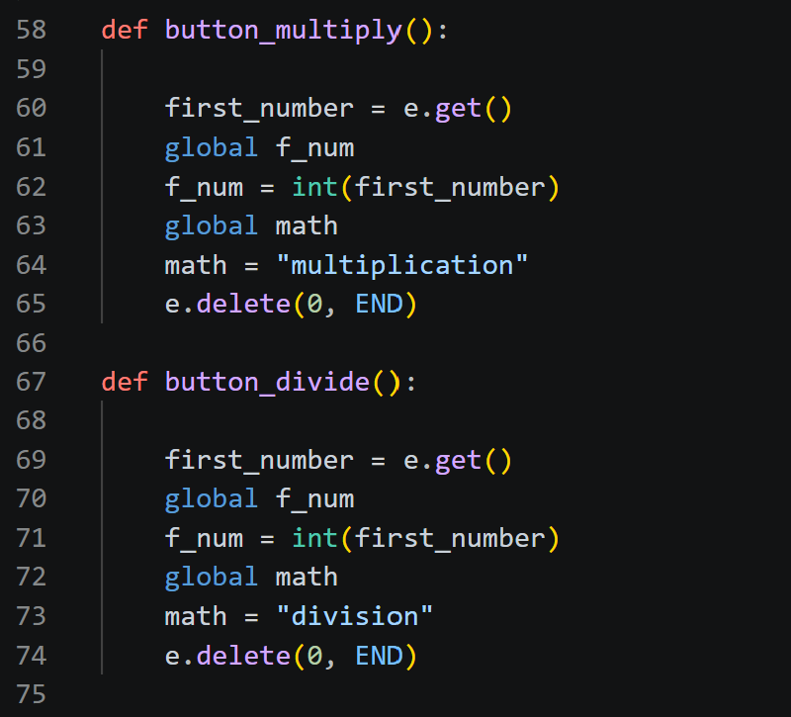
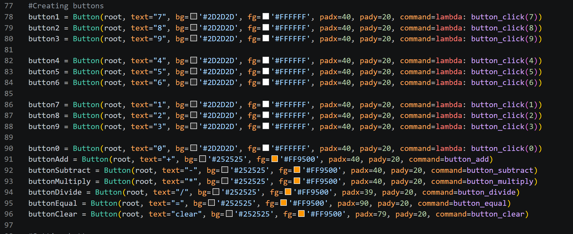
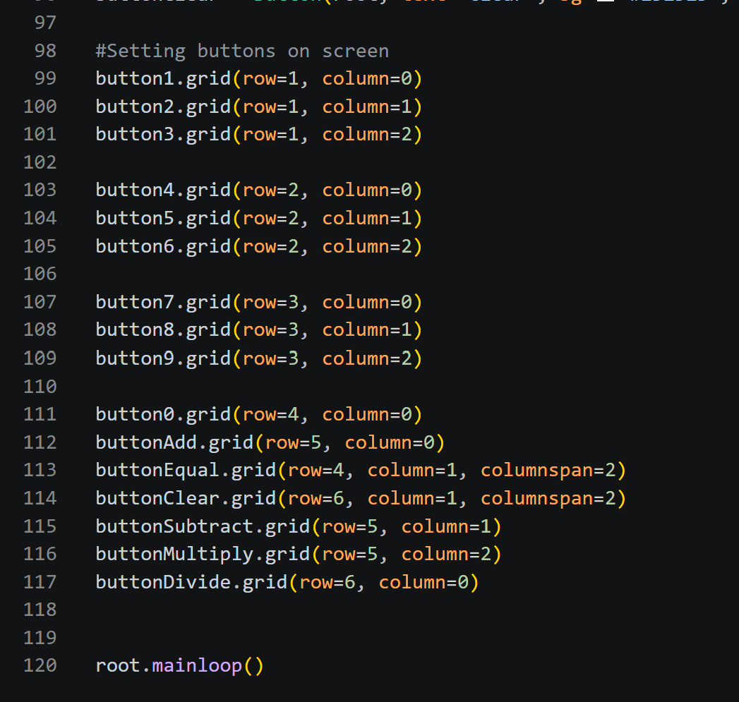

1. Imports and Root Setup

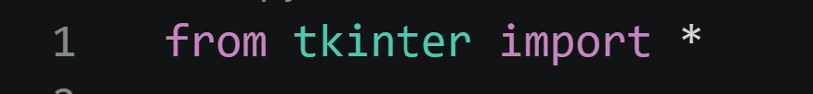
Imports all Tkinter classes and functions so we can use them without the tk. prefix.
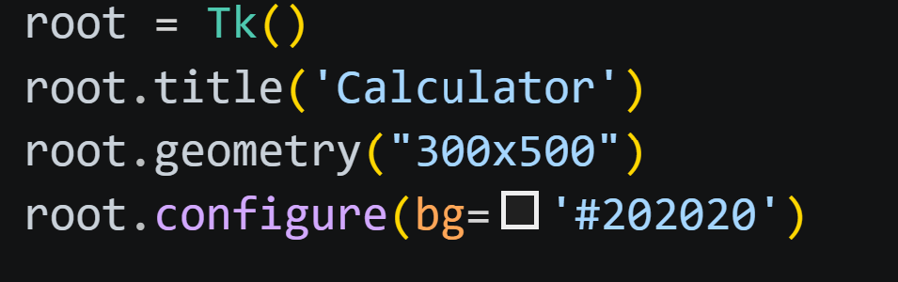
- root = Tk() creates the main window.
- title() sets the window title.
- geometry() sets the initial size (300×500 pixels).
- configure(bg='#202020') sets the background color to a dark gray (hex #202020).

2. Entry Widget (Display)

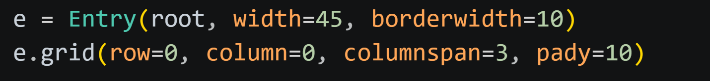
- Creates an Entry widget to display numbers and results.
- width=45 – visible width in characters.
- borderwidth=10 – thick border around the entry.
- grid() places it in row 0, column 0, spanning 3 columns (columnspan=3) so it stretches across the top.
- pady=10 adds vertical padding (space above and below).

3. Number Button Function

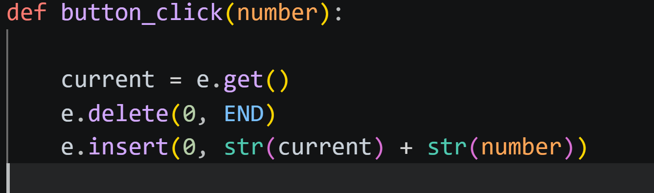
- Gets the current text from the entry (e.get()).
- Deletes all text from the entry (delete(0, END) – from index 0 to the end).
- Inserts the old text concatenated with the new number as a string.
- This allows building multi-digit numbers.

4. Clear Function

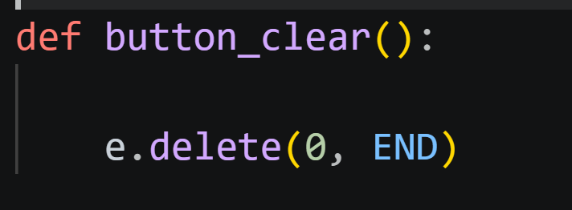
Simply clears the entry field.

5. Operation Functions (Add, Subtract, Multiply, Divide)
The pattern is the same for all four operations. Let's look at button_add:
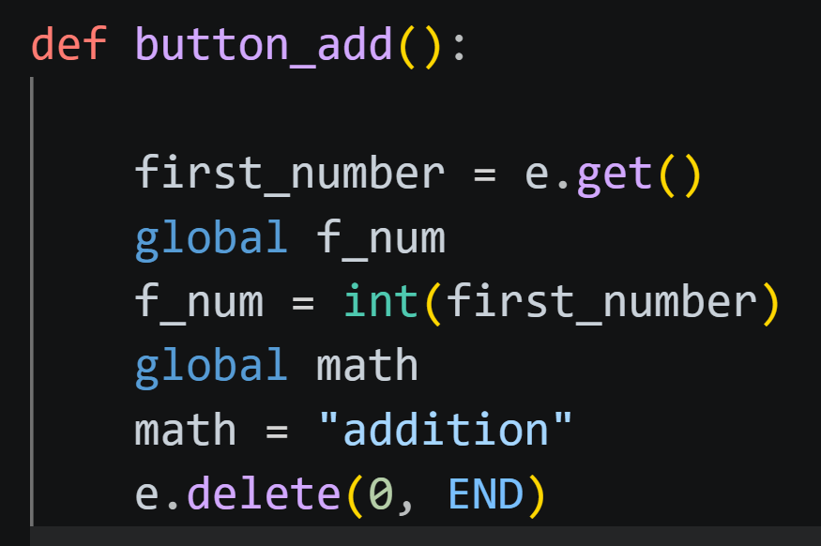
- Gets the current number from the entry and converts it to an integer.
- Stores it in a global variable f_num (first number).
- Stores the operation type in another global variable math.
- Clears the entry so the user can enter the second number.
Similarly, button_subtract, button_multiply, and button_divide set math to "subtraction", "multiplication", and "division" respectively.

6. Equal Function (Perform Calculation)

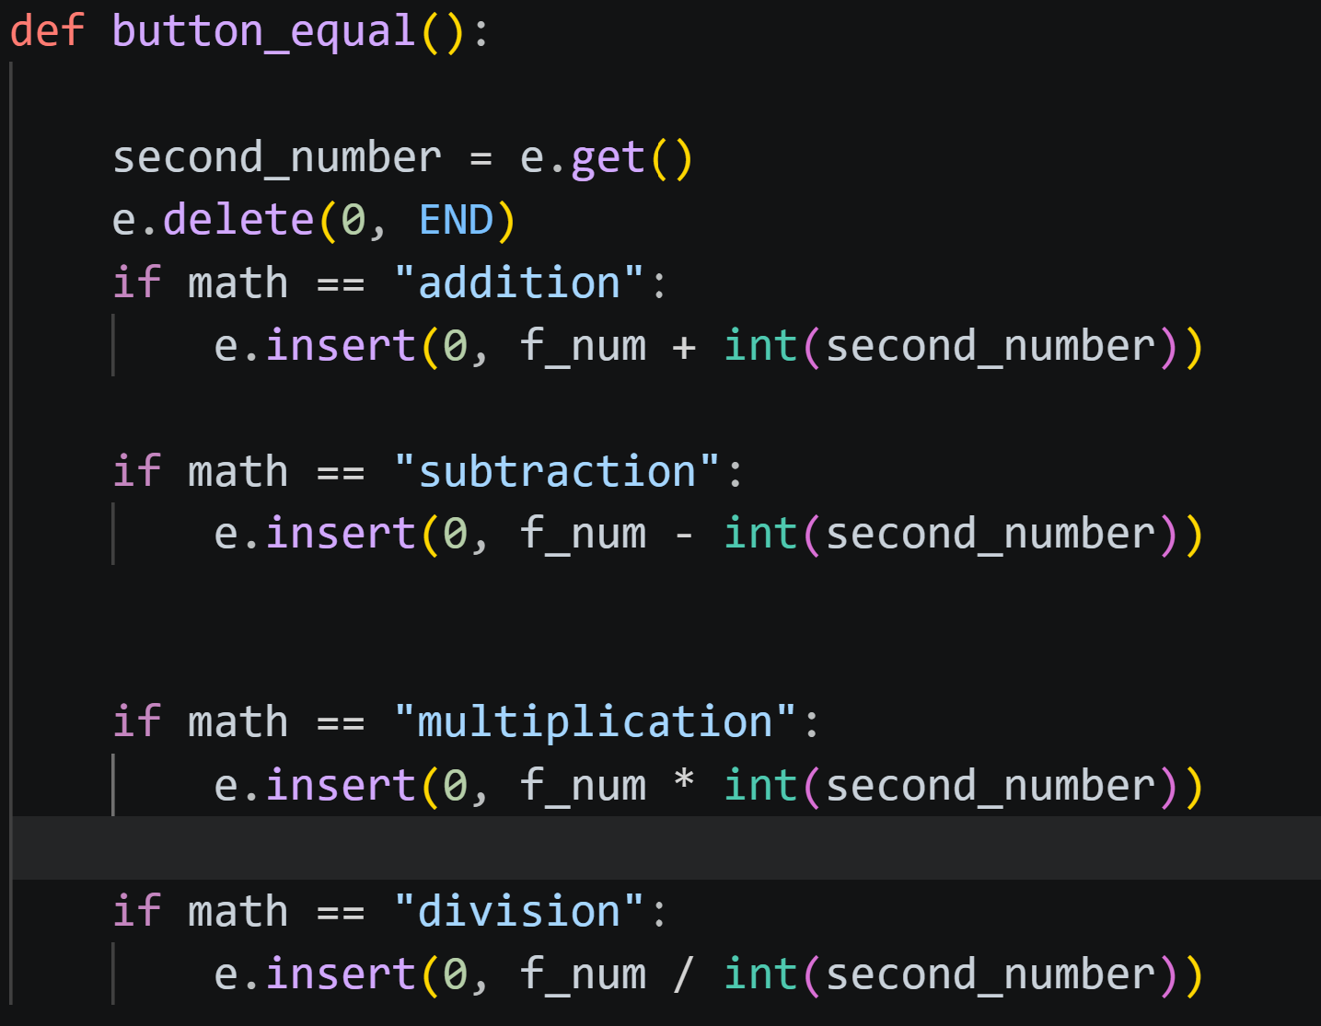
- Gets the second number from the entry.
- Clears the entry.
- Depending on the stored math value, performs the corresponding operation between f_num and the second number.
- Inserts the result into the entry.
- Potential issue: Division by zero is not handled – if the user divides by zero, an error will occur.

7. Button Creation
Each button is created with a similar pattern. For example:
- text – label on the button.
- bg – background color (dark gray).
- fg – foreground (text) color (white).
- padx, pady – internal padding to make the button bigger.
- command – specifies the function to call when clicked.
  - For number buttons, we use lambda: button_click(7) so that we can pass the number 7 to button_click. Without lambda, command=button_click(7) would call the function immediately at creation.
The other number buttons are similar, just changing the number and the lambda argument.
Operation buttons use the functions directly without lambda because they don't need arguments:
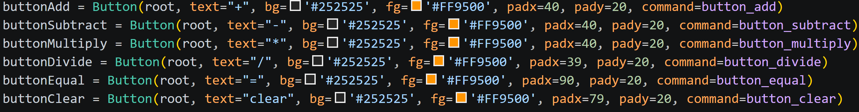
Equal and Clear similarly use button_equal and button_clear.

8. Button Layout with Grid
The calculator buttons are placed in a grid that mimics a typical calculator layout.
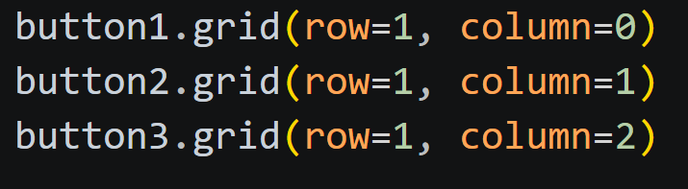
Row 1, columns 0–2: 7, 8, 9.
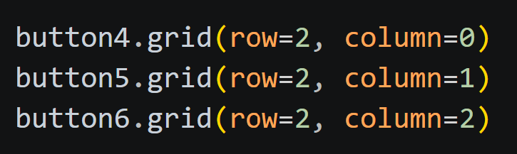
Row 2: 4, 5, 6.
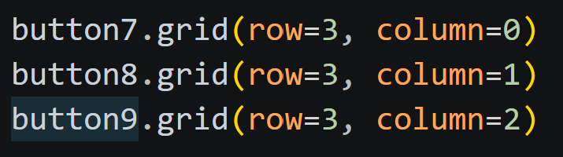
Row 3: 1, 2, 3.
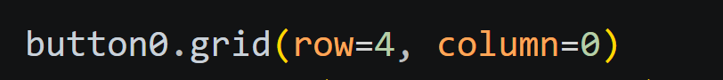
Row 4, column 0: 0.
- buttonAdd (plus) goes in row 5, column 0.
- buttonEqual spans columns 1 and 2 (columnspan=2) in row 4, making it wider.
Clear button spans columns 1–2 in row 6.
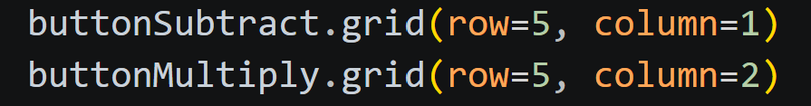
Subtract and multiply buttons in row 5, columns 1 and 2.
Divide button in row 6, column 0.
Row indexes:
- Row 0: Entry display (spanning all columns)
- Row 1: 7 8 9
- Row 2: 4 5 6
- Row 3: 1 2 3
- Row 4: 0 and Equal (equal spans two columns)
- Row 5: + - *
- Row 6: / Clear (clear spans two columns)

9. Event Loop

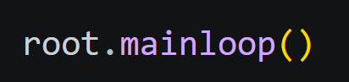
Starts the Tkinter event loop, keeping the window open and responsive.

Sixth tkinter program
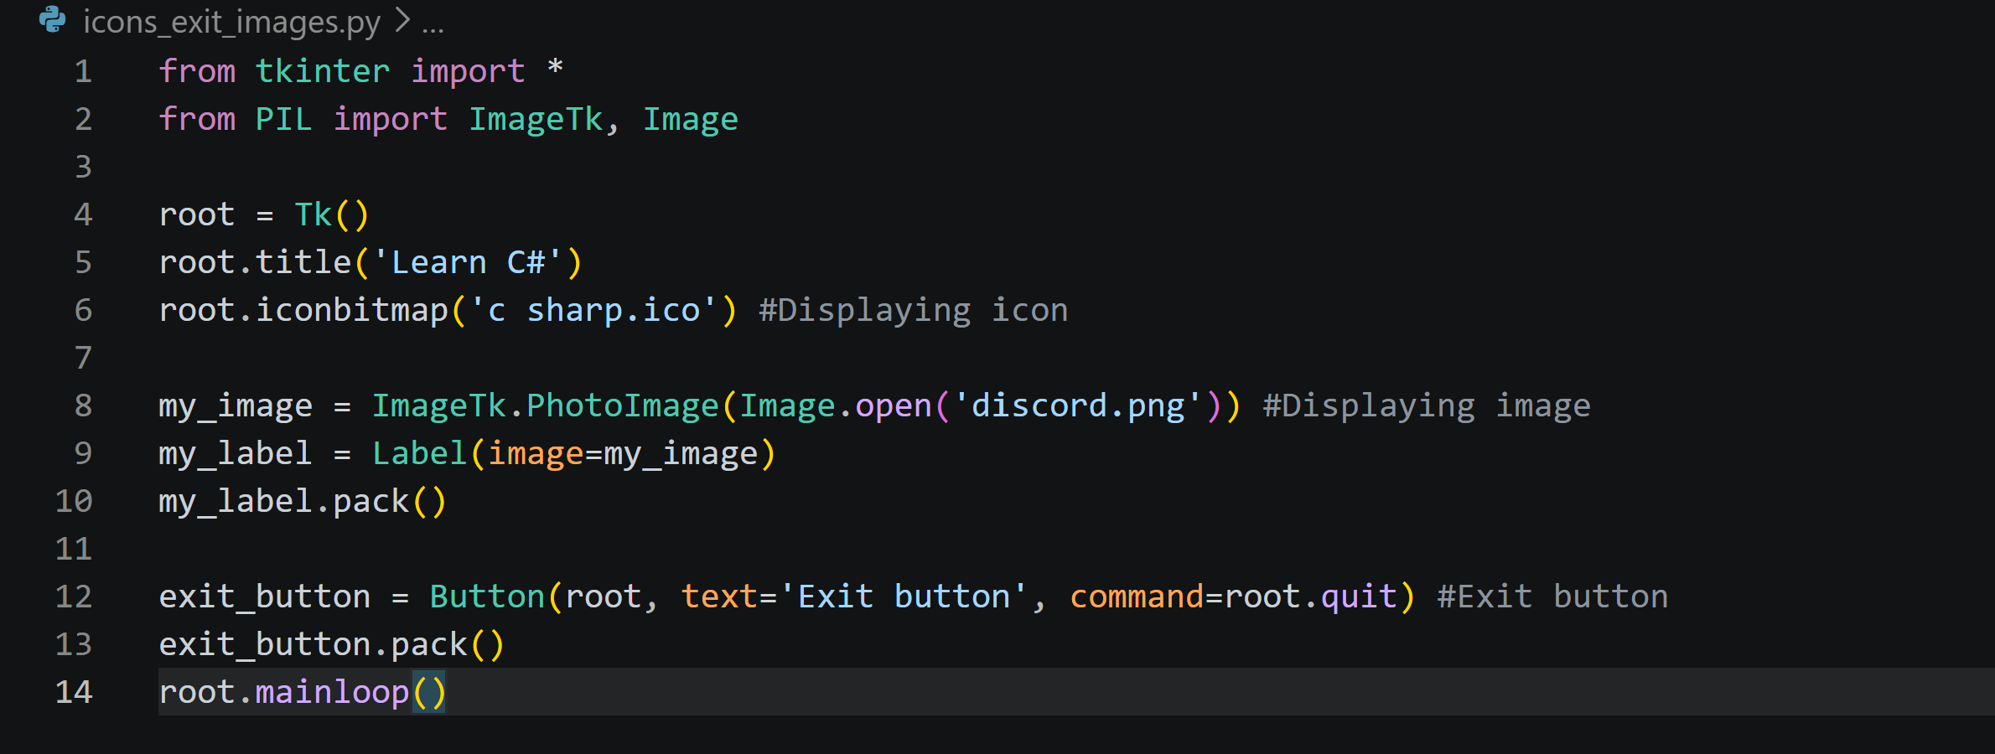

1. Imports

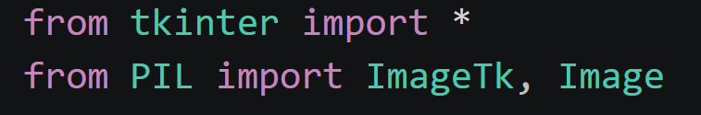
- from tkinter import * – imports all Tkinter classes and functions (e.g., Tk, Label, Button, PhotoImage).
- from PIL import ImageTk, Image – imports two modules from the Pillow library (which is an updated fork of PIL).
  - Image – used to open and manipulate image files (like PNG, JPEG, etc.).
  - ImageTk – provides PhotoImage that can convert PIL Image objects into Tkinter-compatible images.
Note: Pillow is not part of the standard library. You need to install it with pip install pillow. Without it, the code will fail.

2. Creating the Main Window

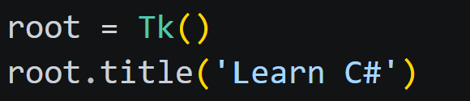
- root = Tk() creates the main application window.
- root.title('Learn C#') sets the window's title to "Learn C#".

3. Setting a Window Icon
- iconbitmap() sets the icon that appears in the window title bar (and taskbar) to the specified .ico file.
- The file 'c sharp.ico' should be in the same directory as the Python script. If the file is missing or the path is incorrect, this line will raise an error.

4. Loading and Displaying an Image

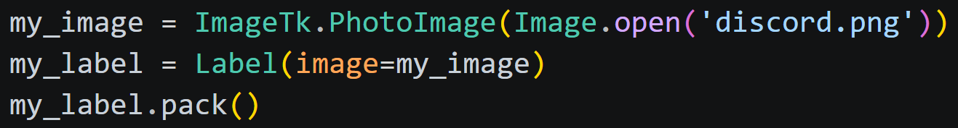
- Image.open('discord.png') opens the PNG file using Pillow. It returns a PIL Image object.
- ImageTk.PhotoImage() converts that PIL Image into a Tkinter-compatible image object that can be used with Tkinter widgets like Label, Button, etc.
- my_label = Label(image=my_image) creates a Label widget whose image option is set to the converted image. No text is shown.
- my_label.pack() adds the label to the window, causing the image to appear.
Important: The variable my_image must be kept as a reference (global or persistent) otherwise Python’s garbage collector may delete it, and the image won’t show. Here it’s stored in a variable that stays alive while the script runs.

5. Exit Button
- Creates a Button widget with the text "Exit button".
- command=root.quit – when the button is clicked, it calls root.quit(), which stops the Tkinter main loop and closes the window.
- The button is packed below the image.

6. Starting the Application

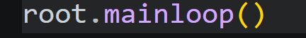
- Enters Tkinter’s event loop. The window stays open and interactive until the user closes it or the quit() method is called.

